Effect of Gain in Closed-Loop Systems Position Feedback

ME4160: Control Lab - L01
Bobby B. Lyle School of Engineering, Southern Methodist University

Experiment: DATE (10/16/2017)

Submitted by
Osama AlOlabi [46670004]
DATE
10/22/2017

I, Osama AlOlabi, acknowledge that in preparation of the following document, I have abided by the SMU honor code (https://www.smu.edu/StudentAffairs/StudentLife/StudentHandbook/HonorCode), and the online submission of this document in Canvas represents my agreement to all consequences of violation of SMU honor code.

Objective:
In this lab, we try to measure the rise time, peak time, settling time, steady state error, and percent of overshoot with different gain values. We also get to know the difference between using angular and velocity.

Procedure:

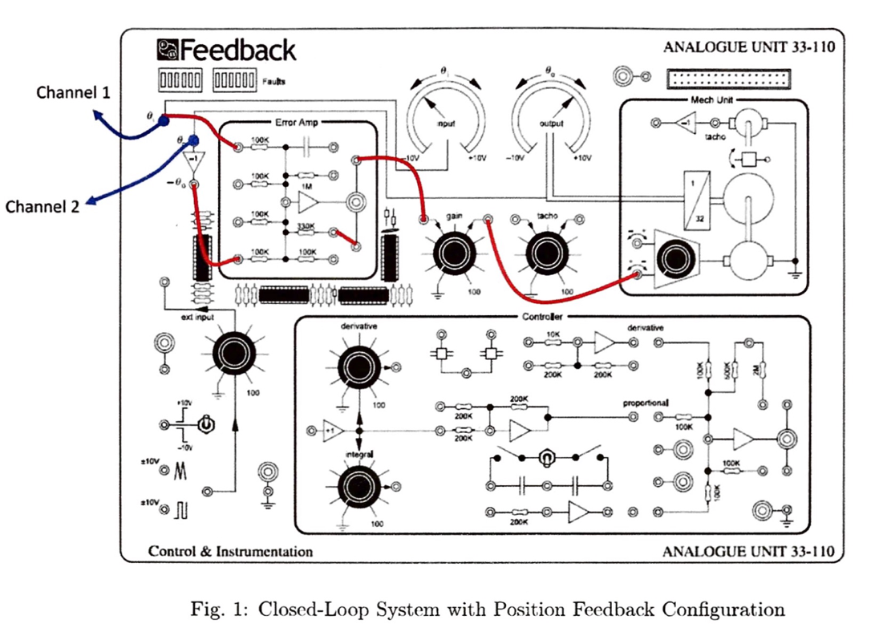
We started by setting up the position of the feedback closed-system shown in Fig. 1

The gain was set on different powers starting from 20% till full gain 100%. Then we would disconnect the wire from initial theta to the 100K op-Amp and at the same time we would freeze the response that was showing on the oscilloscope and set the angular knob on 90 degrees, after that we would reconnect it again. We then would start measuring each of the rise time, peak time, settling time, stead state error, and percent of overshoot. We redid the same thing but with the angular knob on -90 degrees.

Results:

Fig. 1: shows rise time vs gain

Fig. 2: shows peak time vs gain

Fig. 3: shows settle time vs gain

Fig. 4: shows steady state error vs gain

Fig. 5: shows percent overshoot vs gain

Discussion:

We notice that with the negative angle it ends up being higher than the positive one. But in the percent overshoot it starts and ends higher than the positive one. An open loop would have a slower response to reach steady state. The reason why we disconnect the wire instead of turning the knob is that we can have the sudden change, if we rotate the knob then we go through all the degrees from 0 to 90. Getting into more details, Rise time is when the system goes from 5% to 90%. Settling time is how much time has elapsed from the start of the input to the output. The overshoot is the max value we get subtracted by 1Peak time is when we are able to reach the overshoot. Steady state error is the difference between the final output and the actual one.

Appendix 1: Raw Data

Table. 1: Raw data gathered in lab
 | Gain | Rise Time (ms) | Peak Time (ms) | Settling Time (ms) | Steady State Error (V) | Percent Overshoot (%)
0 to 90 | 20 | 760 | 1320 | 2920 | 0 | 15
0 to 90 | 40 | 480 | 1000 | 2960 | 0 | 30
0 to 90 | 60 | 360 | 720 | 3320 | 0 | 38
0 to 90 | 80 | 280 | 600 | 4100 | 0 | 46
0 to 90 | 100 | 250 | 520 | 4360 | 0 | 47
0 to -90 | 20 | 640 | 1400 | 2360 | 0 | 25
0 to -90 | 40 | 520 | 960 | 3120 | 0 | 41
0 to -90 | 60 | 320 | 720 | 3360 | 0 | 50
0 to -90 | 80 | 240 | 540 | 4200 | 0 | 66
0 to -90 | 100 | 320 | 640 | 4480 | 0 | 66

Reference
Lab manual.

